IBM Capstone project

Moving house after COVID19

Fabrizio Ruffini



# **Abstract**

After the **COVID-19 outbreak**, the working habits will likely change from an office-centered perspective to a more **home-based** culture with a prevalence of **smart-working approach**. Thus, moving to cities where the life quality is higher, and in particular to green neighborhoods will possibly become important, also to provide your family with a **sane** and **safe** environment where to live.

In this analysis we are going to compare the **four main Italian cities** in terms of **pollution** with a focus on **air quality**, and once we chose the "most interesting one" we will look for an **appealing neighbourhood** in terms of life quality, looking at the availability of green areas (parks, gardens...), small shops and also their crowd-levels.

## **Introduction**

### Business problem

Moving from house to house is one of the most interesting business case. After the covid19 outbreak, it is likely that our moving preferences will change; for example, the lockdown experience allowed us to better appreciate large internal spaces and the possibility of having a garden outside. In addition, the working habits will likely change from an office-centered perspective to a more **home-based** culture with a prevalence of **smart-working approach.** In this context, while moving house you will naturally give more and more attention to information about safe and sane neighbour environment. In this analysis we are going to compare the **four main Italian cities** in terms of **pollution** with a focus on **air quality**, and once we chose the "most interesting one" we will look for an **appealing neighbourhood** in terms of life quality, looking at the availability of green areas (parks, gardens...), small shops and also their crowd-levels.

### Stakeholders

**Estate agents** are naturally interested in all added value insights that can represent a competitive advantage with respect to other companies. In particular, more and more interest is currently given to green topics, and we expect that the health topic will become more and more important after the current 2020 situation.

# **Data acquisition and description**

## Pollution data

Pollution data are taken from Copernicus Atmosphere dataset. As a representative dataset, we took the whole 2019 year, and we also added the most recent data available at the time of the analysis (up to June 2020).

The pollutant variables chosen are NO2, O3, PM2.5, PM10. Note that there are also additional pollutants, such as SO2, CO, NO, toluene, benzene and many harmful others. They are not treated here.

**NO2**: nitrogen dioxide level measured in μg/m³.

* Source: In cities comes from motor vehicle exhaust (about 80%), petrol, metal refining, electricity generation from coal-fired power stations.
* Effect: Long-term exposure is a cause of chronic lung diseases, and are harmful for the vegetation. Nitrogen Dioxide is gaseous air pollutants which is released mainly during fuel combustion from the reaction of nitrogen and oxygen gases. Coughing, wheezing or difficulty breathing

More about NO2 and its effects can be found here <https://www.epa.gov/no2-pollution/basic-information-about-no2>

**O3**: Ground-level Ozone measured in μg/m³. Ozone is a gas that is formed when nitrogen oxides react with a group of air pollutants known as ‘reactive organic substances’ in the presence of sunlight.

* Source: Emitted by cars, power plants, industrial boilers, refineries, chemical plants.
* Effect: High levels can produce asthma, bronchitis or other chronic pulmonary diseases in sensitive groups or outdoor workers. Also, chest pain, coughing, throat irritation, and airway inflammation.

More about O3 and its effects can be found here <https://www.epa.gov/ground-level-ozone-pollution/ground-level-ozone-basics>

**PM2.5**: Besides gaseous pollutants, the atmosphere can also be polluted by particles. These particles have a divergent composition and size and are sometimes called aerosols. They are often catalogued as ‘floating dust’, but are best known as particulate matter (PM). PM2.5 are particles smaller than 2.5 μm level measured in μg/m³. The size of these particles allow them to penetrate into the gas exchange regions of the lungs (alveolus) and even enter the arteries.

* Source: Formed from construction sites, unpaved roads, fields, smokestacks or fires.
* Effect: Irregular heartbeat, aggravated asthma, decreased lung function. Long-term exposure is proven to be related to low birth weight and high blood pressure in new-born babies.

More about PM and its effect here <https://www.epa.gov/pm-pollution/particulate-matter-pm-basics>

**PM10**: particles smaller than 10 μm. Even though the cannot penetrate the alveolus, they can still penetrate through the lungs and affect other organs.

* Source: Formed from construction sites, unpaved roads, fields, smokestacks or fires.
* Effect: Irregular heartbeat, aggravated asthma, decreased lung function. Long term exposure can result in lung cancer and cardiovascular complications.

More about PM and its effect here <https://www.epa.gov/pm-pollution/particulate-matter-pm-basics>

**AQI**: Using pollutant variables it is possible to evaluate an index called **air quality index (AQI)** used by government agencies to communicate to the public how polluted the air and to easy understand the correlated risks. Over the time, there has been different air quality indices. In the following, we will use the definition based on this document from EPA (Environmental Protection Agency of United States). <https://www.epa.gov/sites/production/files/2014-05/documents/zell-aqi.pdf>. AQI converts the measured pollutant concentrations in a communities’ air to a number on a scale of 0 to 500 and above. Preferred way to communicate is via a color-coded Air Quality Index (AQI) that is easy for the public to understand. It provides indicator of the quality of the air and its health effects as shown in the following tables.

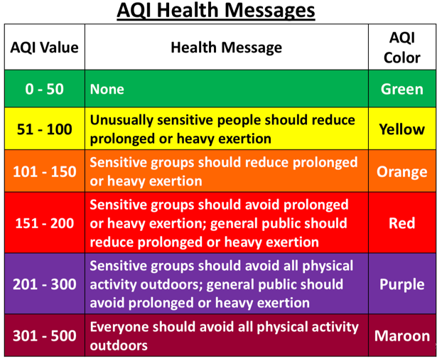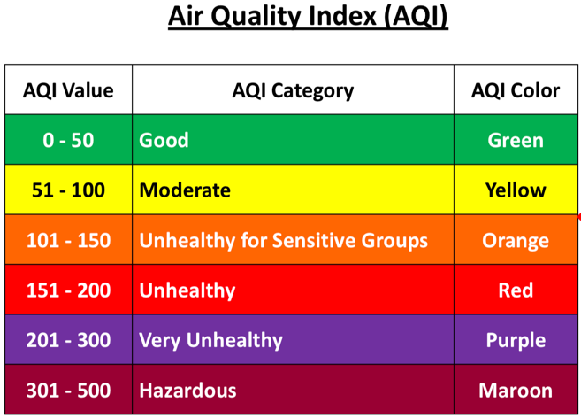

Figure 1: AQI Health messages from ref aq2

Figure 2: AQI categories from ref aq2

## Neighbourhoods life quality data

Neighbourhoods life quality data are taken from google and Foursquare opendata APIs.

**Venue data**

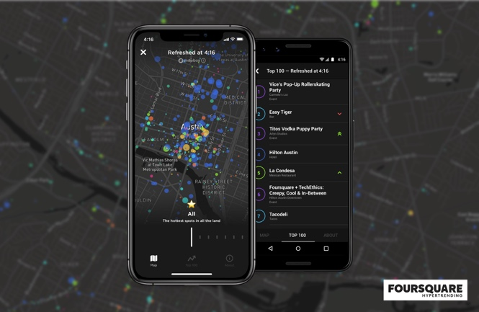Foursquare Places Database allows you to access precise, up-to-date community-sourced venue data. There is a large selection of rich and firmographic location data with the description of locations and trends info. In particular:

* 60M+ commercial POI including restaurants, shops & services, and more
* 941 Venue Categories [(full list available here)](https://developer.foursquare.com/docs/build-with-foursquare/categories/), updated quarterly
* 1M+ fresh* Tips
* 18.5M+ fresh* Photos
* 1M+ Tastes, popular search terms generated by our consumer app users
* 23K+ Chains, including top QSRs, retailers, auto dealerships, and more
* 7.6M+ Venues with popular hours

*Added within the past six months from June 2020

Foursquare database details can be found here <https://developer.foursquare.com/docs/places-database/details/>

**Popular times data**

Google will be used to find **Popular times, wait times, and visit duration information** of cities’ places (ref: <https://support.google.com/business/answer/6263531?hl=en>). This data is the one that appears below the regular business information on Google Maps and Search.

To determine popular times, wait times, and visit duration, Google uses aggregated and anonymized data from users who have opted in to Google Location History. Popular times, wait times, and visit duration are shown for your business if it gets enough visits from these users.

Visit data may include:

* **Popular times graph**: This graph shows how busy your location typically is during different times of the day. Popular times are based on average popularity over the last few months. Popularity for any given hour is shown relative to the typical peak popularity for the business for the week. For example, in the image below, 8 PM–9 PM on Saturday is one of the more popular times of the week for this business.
* **Live visit data**: This data shows how active your location is right now. Live visit data is updated in real time and overlaid on the popular times graph. For example, in the image below, the highlighted section of the graph represents how active the location is right now compared to its usual level of activity.
* **Visit duration**: This data shows how much time customers typically spend at your location. Visit duration estimates are based on patterns of customer visits over the last several weeks.
* **Wait time estimates:**This data shows how long a customer would have to wait before they receive service during different times of the day. It also shows the peak wait time for each day of the week. The displayed wait time is based on patterns of customer visits over the last several weeks. Wait time estimation differs for different business types. For instance, a sit-down restaurant's wait time reflects how long customers wait before they are seated.

**Neighbourhood data**

General neighbourhood data such as traffic information, shopping centers, green/entertainment areas and so forth are available from open google api searches, and they will be used to get insights on the neighbourhood life-quality. Google maps api overview can be found here: <https://developers.google.com/maps/documentation/javascript/tutorial>

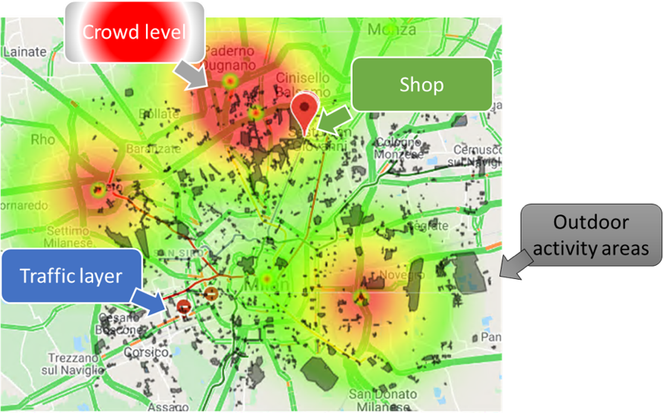

Figure 3: example of info that can be gathered using google API

# **Bibliography**

Info on air quality:

* Aq1: <https://towardsdatascience.com/sensing-the-air-quality-5ed5320f7a56>
* Aq2: <https://www.epa.gov/sites/production/files/2014-05/documents/zell-aqi.pdf>

Info on NO2 <https://www.epa.gov/no2-pollution/basic-information-about-no2>

Info on O3 <https://www.epa.gov/ground-level-ozone-pollution/ground-level-ozone-basics>

Info on PM <https://www.epa.gov/pm-pollution/particulate-matter-pm-basics>

Foursquare data: <https://developer.foursquare.com/docs/places-database/details/>

Google maps data: <https://developers.google.com/maps/documentation/javascript/tutorial>